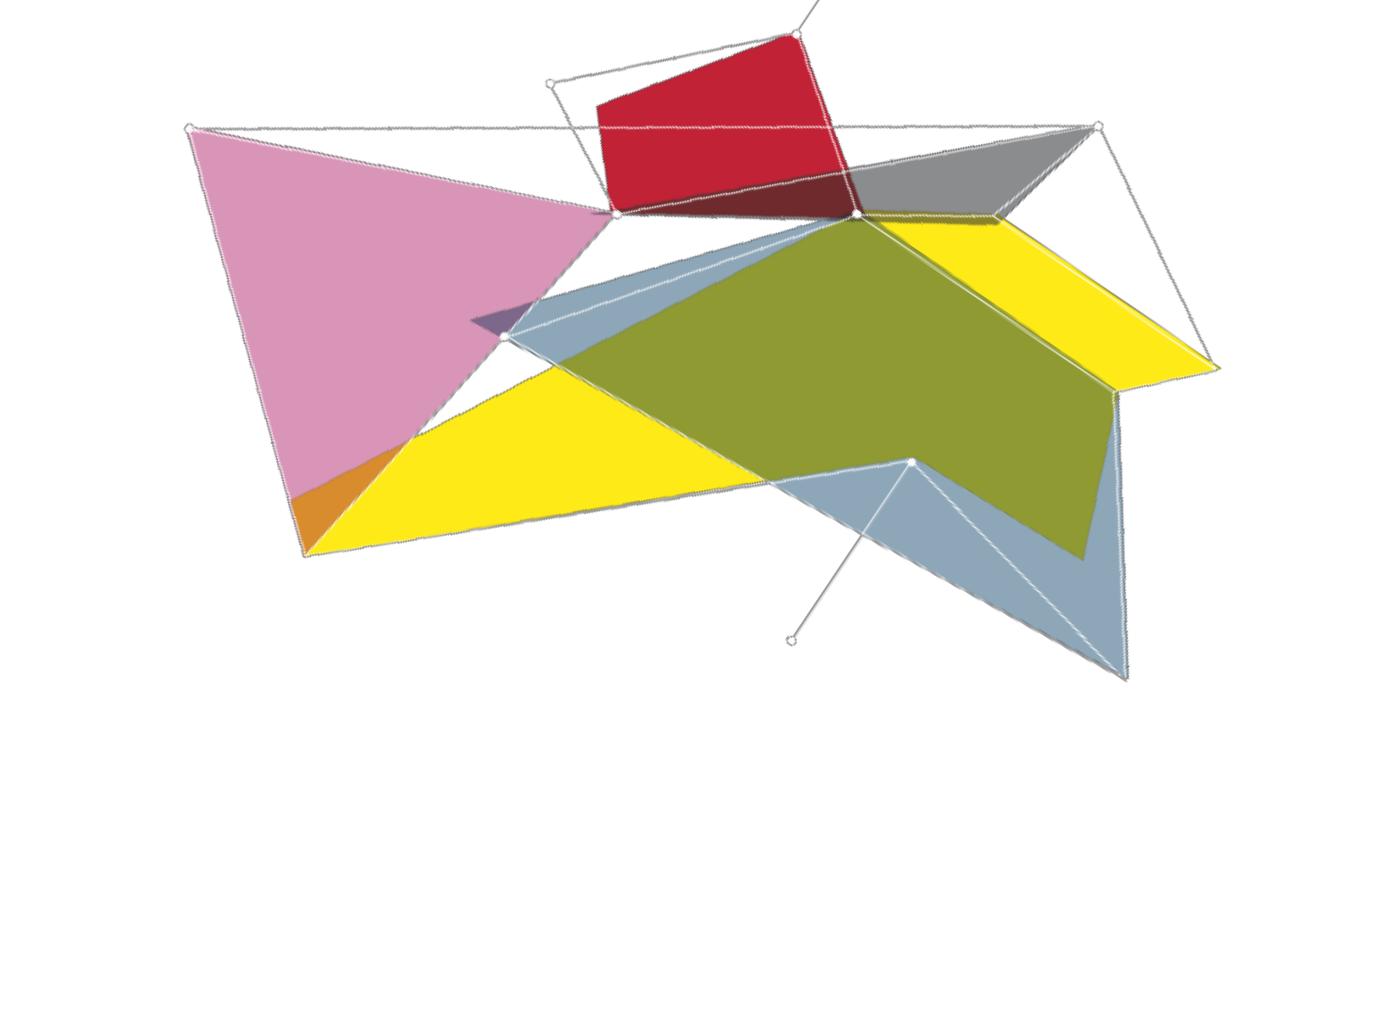

MODULE n.2 | Legal Background
LECTURER | Robert ANDERSON
LECTURE  TITLE | Introduction to the WTO Agreement on Government Procurement
OBJECTIVES | - To familiarize participants with the history, objectives, core elements and recent renegotiation of the WTO Agreement on Government Procurement.  - To provide insight into the benefits and costs of accession to the Agreement, and especially its significance for transition and developing economies.  - To make clear the affinity and complementarity of the Agreement with other international instruments, including the UNCITRAL Model Law, the World Bank's new Procurement  Framework, and the work of EBRD.
DESCRIPTION | The module will begin with a lecture/presentation on the history, objectives, core elements and recent renegotiation of the WTO Agreement on Government Procurement. It will then proceed to a facilitated discussion of the potential benefits and the associated costs and challenges for developing/transition economies in joining the Agreement. Attention will be given to the role of the Agreement as an underpinning of good governance and procurement reforms, in addition to its significance for market access. Reference will be made to the recent experiences of Armenia, Moldova and Ukraine in joining the Agreement and to the ongoing accessions of Tajikistan and the Kyrgyz Republic. Participants will be encouraged to develop/share their own perspectives and relevant experiences.
CLASS MATERIAL | - Robert D. Anderson and Anna Caroline Müller, The revised WTO Agreement on Government Procurement (GPA): key design features and significance for global trade and development (WTO Working Paper ERSD-2017-04, 26 January 2017).  - Robert D. Anderson, Philippe Pelletier, Kodjo Osei-Lah and Anna Caroline Müller, Assessing the Value of Future Accessions to the WTO Agreement on Government Procurement (GPA): Some New Data Sources, Provisional Estimates, and An Evaluative Framework for Individual WTO Members Considering Accession (WTO Staff  Working Paper ERSD-2011-15, October 6, 2011).

