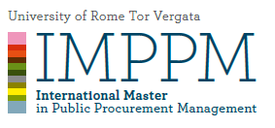

MODULE 12
LAW & ECONOMICS OF PUBLIC AND PRIVATE PARTNERSHIP
Coordinator Professor Biancamaria Raganelli

AVAILABLE TIME | During lectures plus 1 week at home for the case study
DETAILED explanation of the exam  (i.e. multiple choice questions with a short explanation or not, open questions, case studies, and their number) | Case study + concession agreement contract  (please specify % of participation in in group activities)
MATERIAL TO BE STUDIED | Provided during lectures
Is it possible to use the CLASS MATERIAL DURING THE EXAM?  (if YES what kind and specify whether it must be without any notes) | Yes: notes, documents and forms provided
Is it possible to use TRANSLATION DEVICES? | Yes
WEIGHT OF THE EXAM ON THE FINAL GRADE | 80% (case study + contract)
WEIGHT OF EXTRA WORK (class  participation, homework, etc.) ON THE FINAL GRADE | 20%

Prof. …………………

