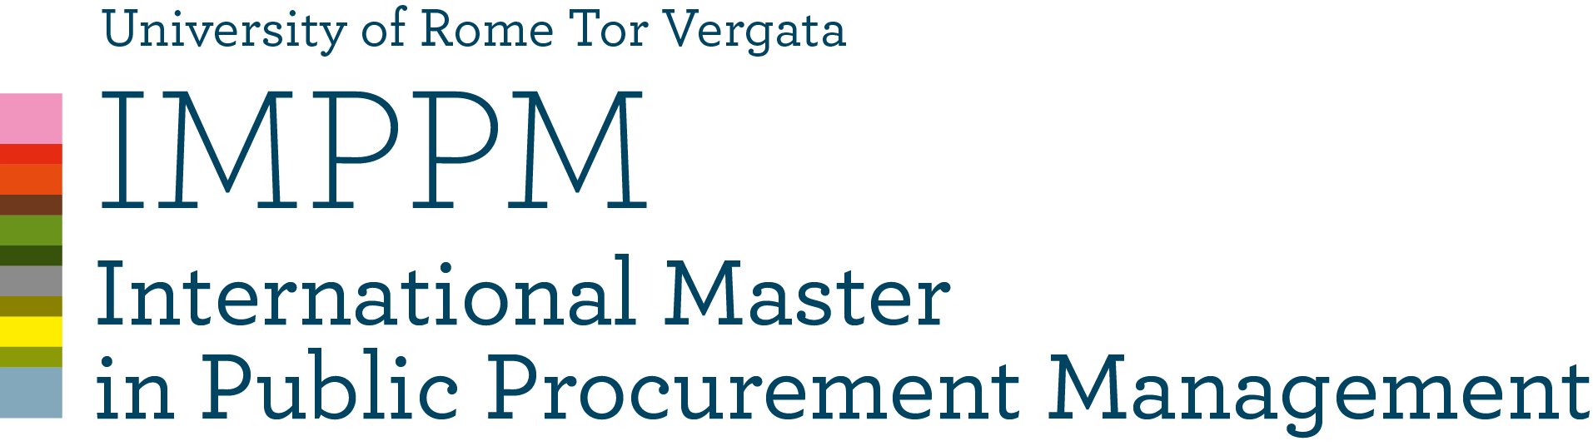

MODULE 6
INTEGRITY AND ANTICORRUPTION IN PUBLIC PROCUREMENT
Coordinator Prof. Gustavo Piga

AVAILABLE TIME | 2 hours
DETAILED explanation of the exam | Part 1 (Piga): 2 open questions  Part 2 (Agerskov): 8 open questions  Part 3 (Fazekas): 2 open questions
MATERIAL TO BE STUDIED | Class lectures
Is it possible to use the CLASS MATERIAL DURING THE EXAM? (if YES what kind and specify whether it must be without any notes) | NO Piga  NO Agerskov  NO Fazekas
Is it possible to use TRANSLATION DEVICES? | YES
WEIGHT OF THE ABOVE EXAM ON THE FINAL GRADE | Piga: 100%  Agerskov: 100%  Fazekas: 50%  The final mark will be the simple average
WEIGHT OF EXTRA WORK (class participation, homework, etc.) ON THE FINAL GRADE | Fazekas: a) class presentation 20%  b) final paper 30%

Prof. Gustavo Piga

