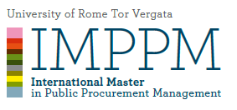

MODULE IV
COMPETITION AND PROCUREMEMENT
Coordinator Prof. Paolo Buccirossi

AVAILABLE TIME | 2 hours
DETAILED explanation of the exam  (i.e. multiple choice questions with a short explanation or not, open questions, case studies, and their number) | Multiple choice questions
MATERIAL TO BE STUDIED | Power Point Presentations and OECD Guidelines
Is it possible to use CLASS MATERIAL DURING THE EXAM? (if YES which one and if it must be without any notes) | NO
Is it possible to use TRANSLATOR DEVICES? | YES
WEIGHT OF THE EXAM ON THE FINAL GRADE | 75% (prof. Buccirossi’s part)
WEIGHT OF EXTRA WORKS (class participation, homeworks, etc.) ON THE FINAL GRADE | 25% (prof. Molden’s cases)

Prof. Paolo Buccirossi

