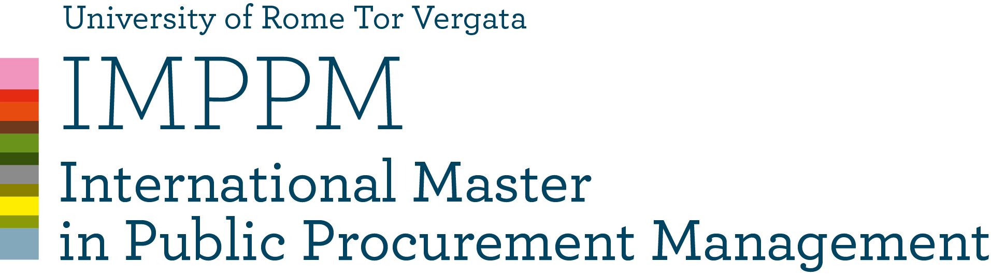

MODULE 3
ECONOMICS OF PROCUREMENT
Coordinator Professor Nicola Dimitri

AVAILABLE TIME | 3 hours
DETAILED explanation of the exam  (i.e. multiple choice questions with a short explanation or not, open questions, case studies, and their number) | There will be two parts: Dimitri and Di Domenicantonio.  Dimitri’s part will consist of 9 questions while Di Domenicantonio’s will consist of three questions (exercises)
MATERIAL TO BE STUDIED | Slides and papers handed in class
Is it possible to use the CLASS MATERIAL DURING THE EXAM? (if YES what kind and specify whether it must be without any notes) | NO
Is it possible to use TRANSLATION DEVICES? | YES
WEIGHT OF THE EXAM ON THE FINAL GRADE | 80% Dimitri’s test 20% Di Domenicantonio’s test
WEIGHT OF EXTRA WORK (class participation, homework, etc.) ON THE FINAL GRADE | NO

Prof. Nicola Dimitri

